Lab Objective

* Install and Configure Windows Server Update Services (WSUS)

**Lab Procedures**

**1.** On Server01, if Server Manager is not open, open Server Manager.

**2.** At the top of Server Manager, click Tools > Windows Server Update Services.

**3.** When the Complete WSUS Installation dialog box opens, click Run.

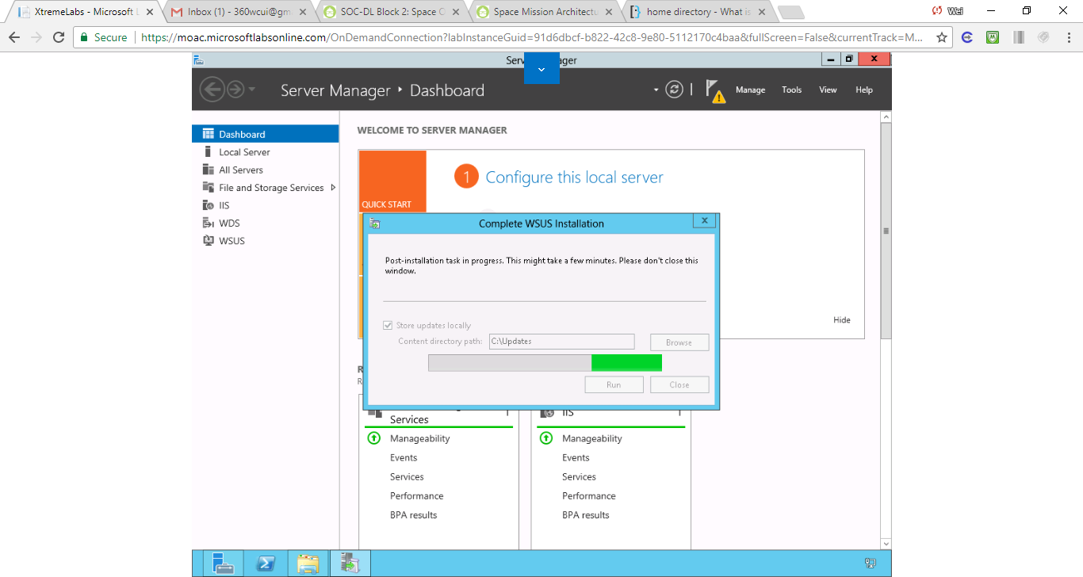

Figure . Step 3 When the Complete WSUS Installation dialog box opens, click Run.

**4.** Take a screen shot of the Complete WSUS dialog box by pressing Alt+Prt Scr and then paste it into your Lab02_worksheet file in the page provided by pressing Ctrl+V.

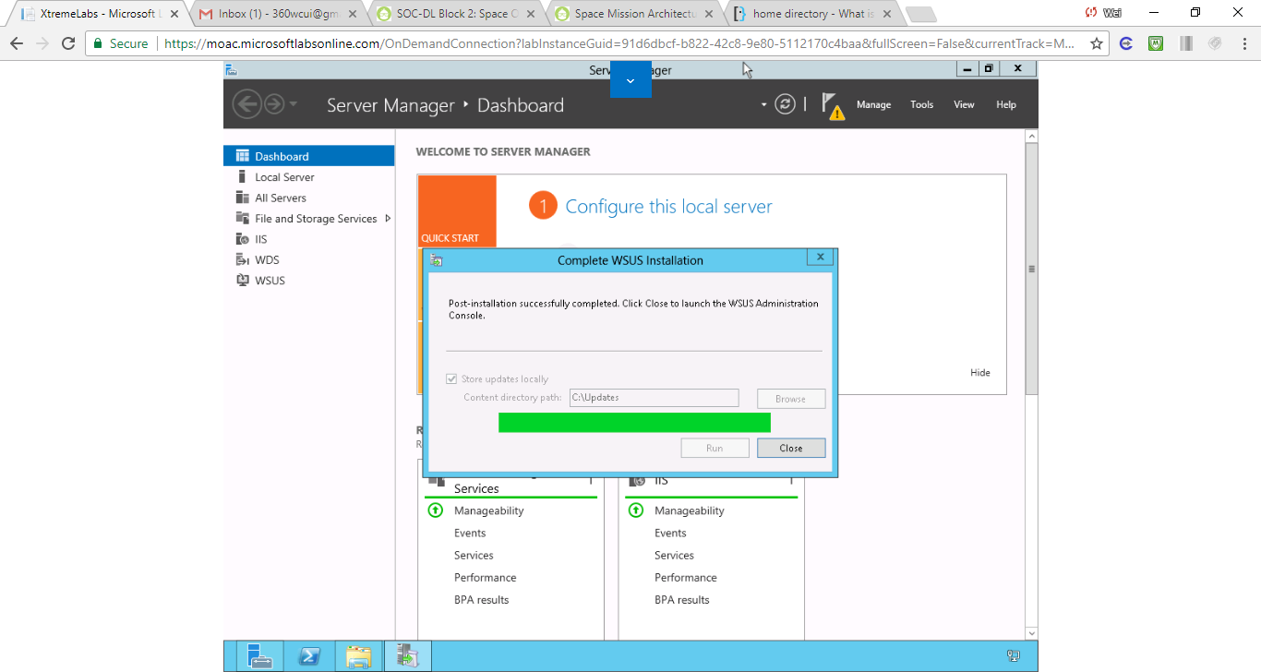

Figure . 4. WSUS Installation is complete.

**5.** When the post-installation successfully is completed, click Close.

**6.** When the Before You Begin page opens, click Next.

**7.** On the *Join the Microsoft Update Improvement Program* page, click Next.

**8.** The Choose Upstream Server page displays, as shown in Figure 2-3. Click *Synchronize from another Windows Server Update Services server*. In the Server name text box, type **server02.contoso.com**. Answer the following question and click Next.

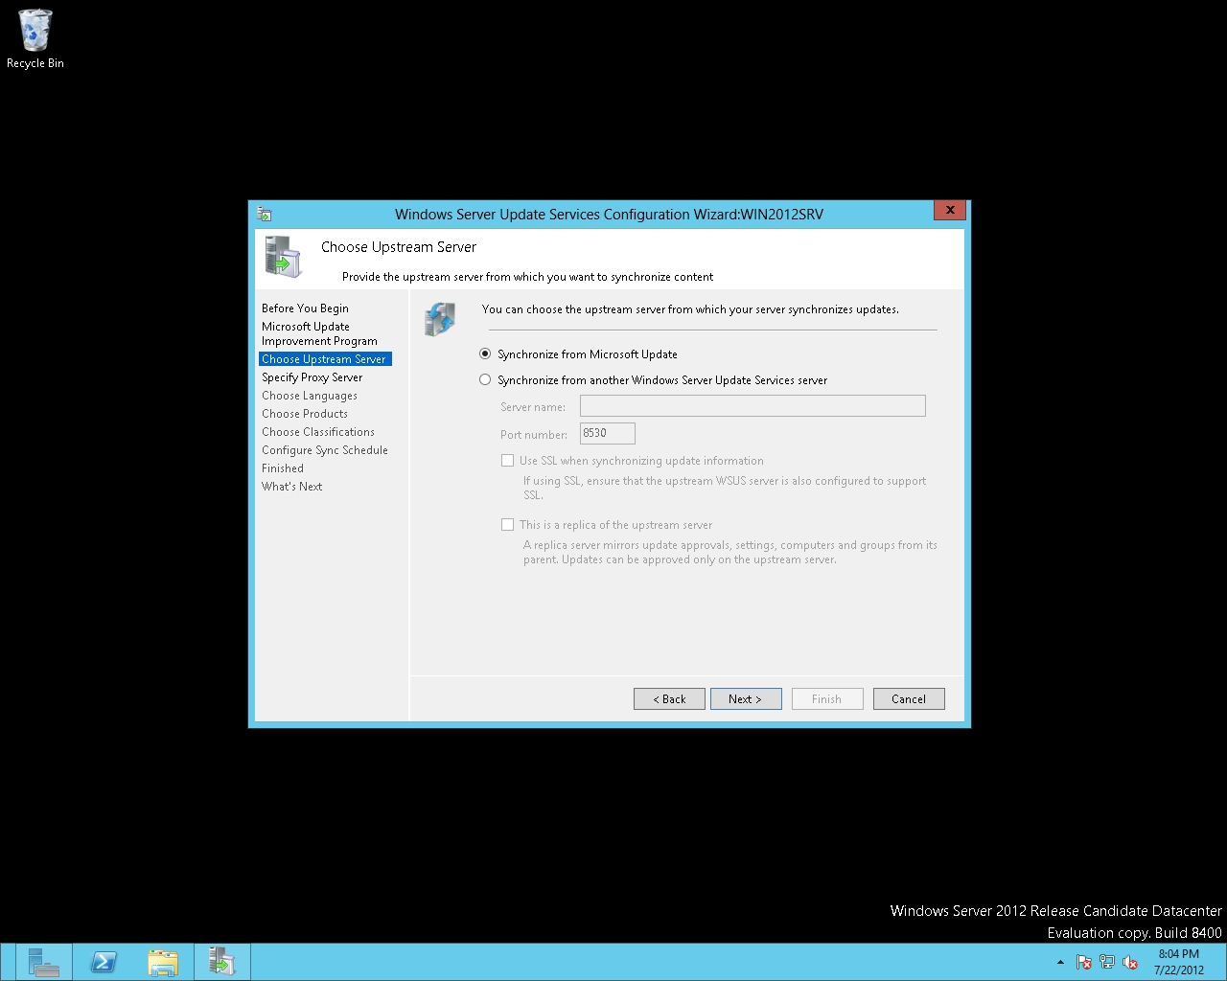

Figure 2-3

Specifying where to get the updates from

**9.** On the Specify Proxy Server page, click Next.

**10.** On the Connect to Upstream Server page, click Start Connecting.

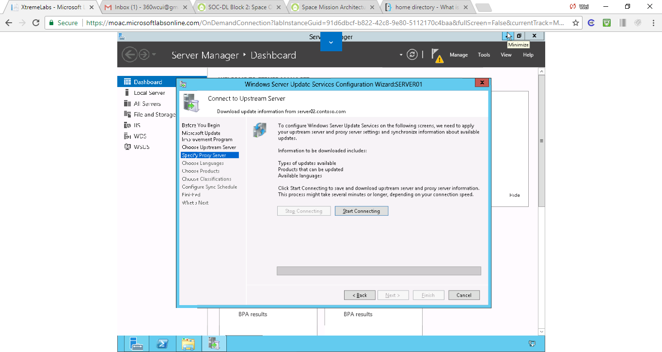

Figure . Step 10. On the Connect to Upstream Server page, click Start Connecting

**11.** When the connection is complete, click Next.

**12.** On the Choose Languages page, choose one language that you need to support, and then click Next.

**13.** On the Set Sync Schedule page (see Figure 2-4), click Next.

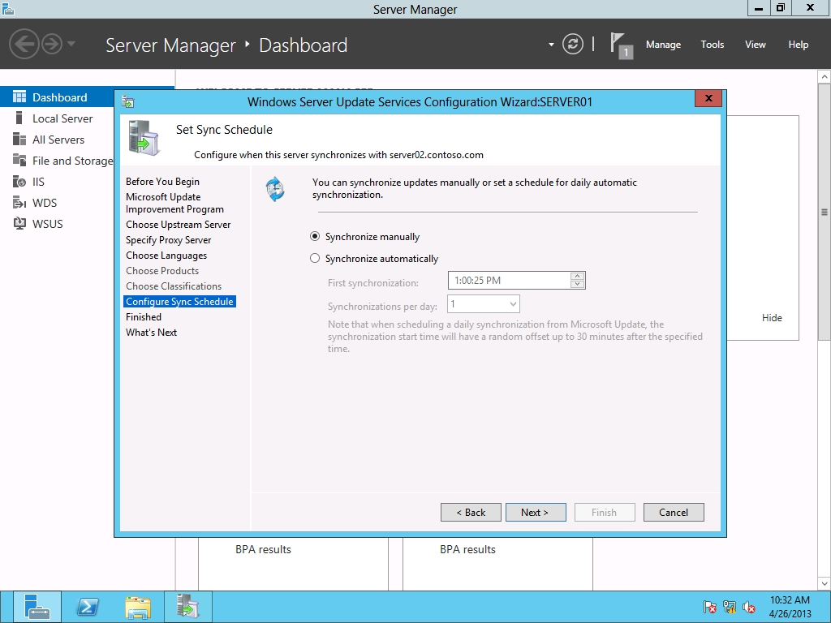

Figure 2-4

Specifying when to sync updates

**14.** On the Finished page, select Begin initial synchronization and then click Next.

**15.** On the What’s Next page, click Finish.

**16.** On the Update Services console, expand Server01, and click Synchronizations.

**17.** Take a screen shot of the Update Services console by pressing Alt+Prt Scr and then paste it into your Lab02_worksheet file in the page provided by pressing Ctrl+V.

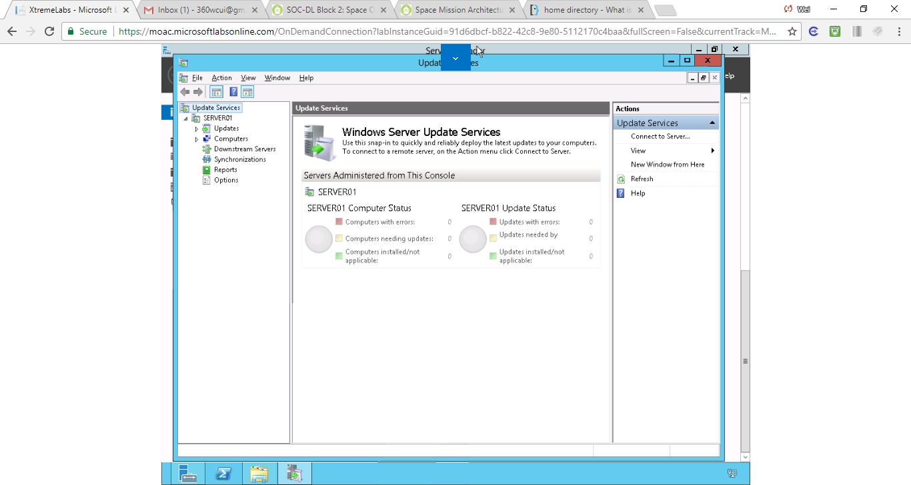

Figure Step 17. Update Services console interface

**18.** Synchronization should already be running. At the bottom of the left pane, click Options to show the WSUS options. View the available options.

**19.** In the left pane, expand Computers so that you can see All Computers.

**20.** Right-click All Computers and choose Add Computer Group. The Add Computer Group dialog box opens.

**21.** In the Name text box, type the **Group1** in the name text box. Click Add to apply your settings and to close the Add Computer Group dialog box.

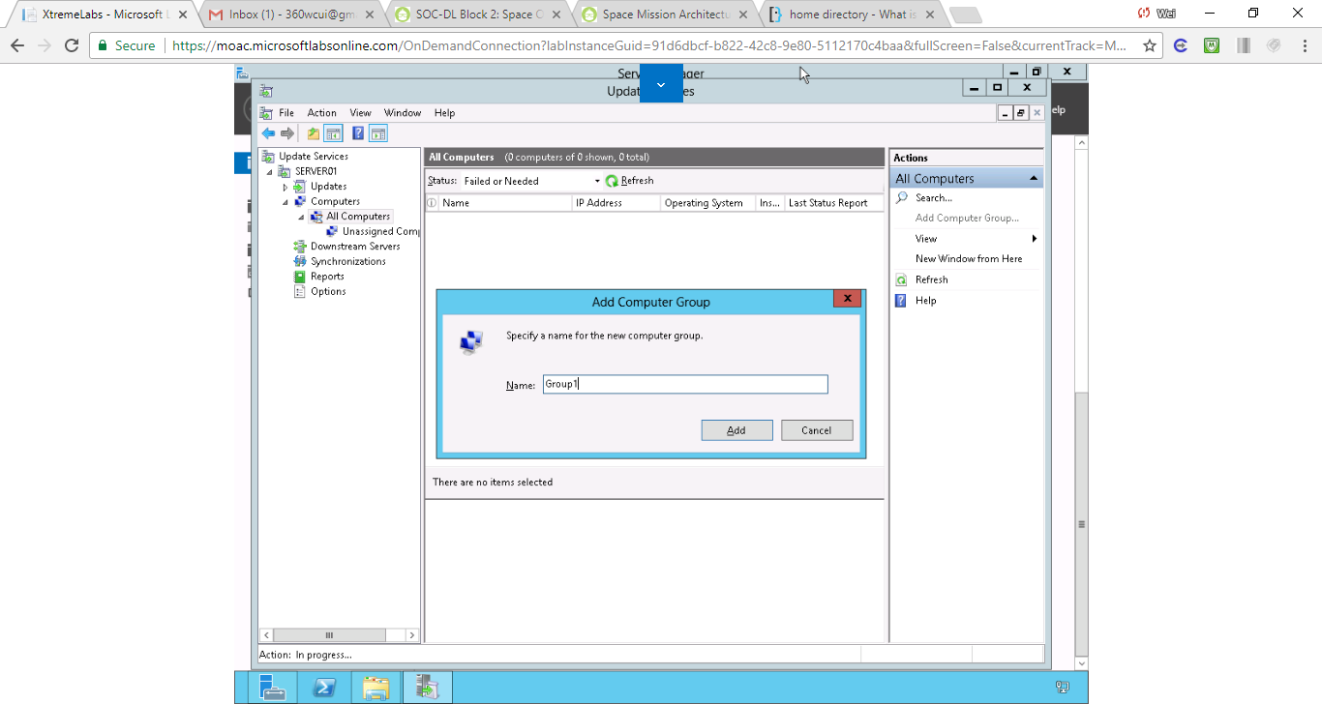

Figure . Step 21. In the Name text box, type the Group1 in the name text box. Click Add to apply your settings and to close the Add Computer Group dialog box

**Lab Review Questions**

In Exercise 2.2, what two sources can a WSUS server get updates from?

Answer: two sources are Microsoft Update and another WSUS server

**Lab Summary**

After I install WSUS, I must configure WSUS so that it retrieves updates from Microsoft or another WSUS server. In this exercise, I learned how to configure WSUS on what updates need to be downloaded and when the downloads should occur.